**EXPERIMENT – 4**

**RELATIONAL MODEL FOR SAILOR BOAT DATABASE**

**Aim:**

Draw a relational model for sailor boat database.

**Components of ER diagram**

**Entity** – An entity is an object that exists in database administration.

**Attribute** – In DBMS an attribute refers to a database component, such as table.

**Primary key** – A primary key is a specific choice of a minimal set of attributes that uniquely specify a tuple in a relation.

**Foreign key** – A foreign key is a set of attributes in a table that refers to the primary key of another table.

**Composite attribute** – It is an attribute where the values of that attribute can be further subdivided into meaningful subparts.

**Derived attribute** – These are the attributes that do not exist in physical database, but their values are derived from other attributes present in the database.

**Relationship** – A relation as originally defined by E.F. codd. Is a situation that exists between two relational database tables.

**Many to many** – refers to a relationship between tables in a database when a parent row in one table contains several child rows in second table, and vice versa….

**RELATIONAL MODEL**

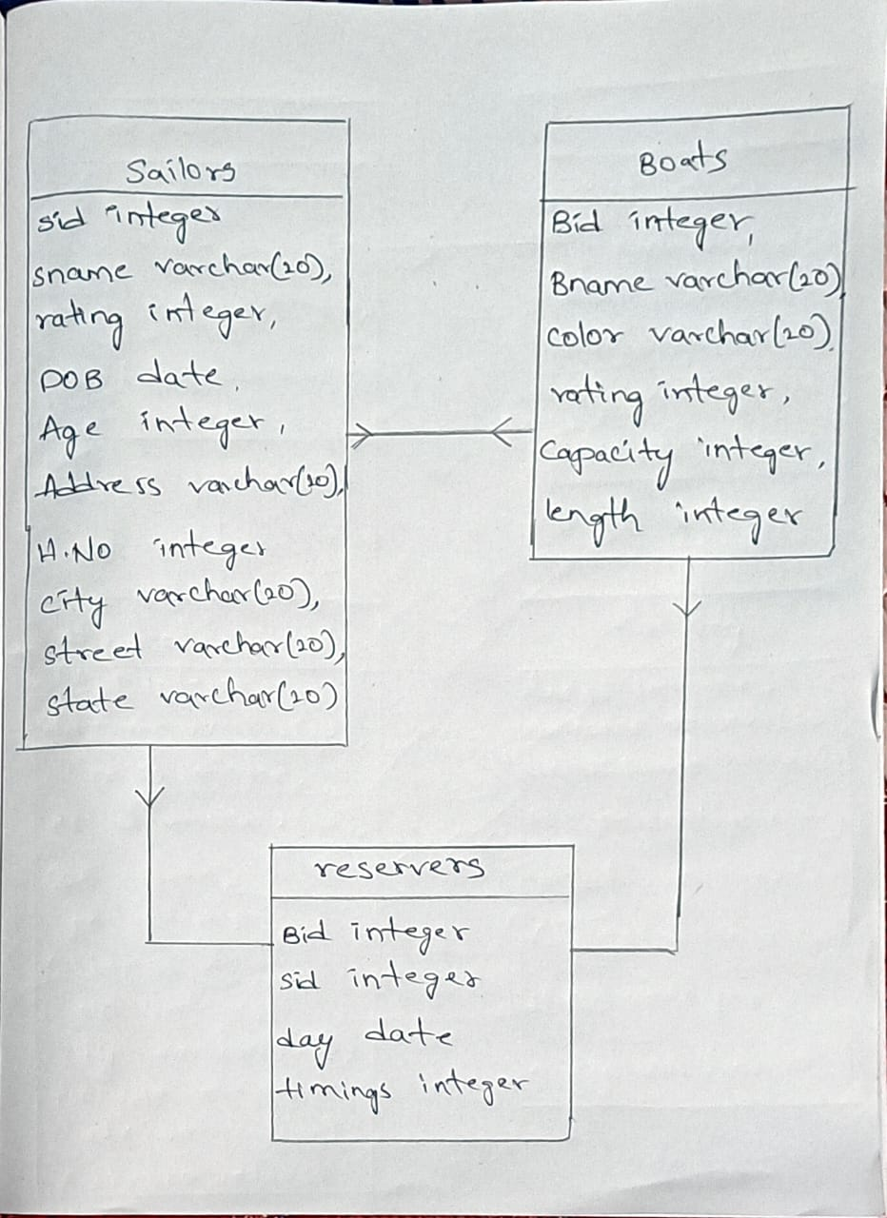

**RELATIONAL MODEL**

BOATS

Bid integer,

Bname varchar (20),

Color varchar (20),

Rating integer,

Capacity integer,

Length integer

SAILOR

Sid integer,

Sname varchar (20),

DOB date,

Age integer,

Address varchar (20),

H.NO integer

City varchar (20),

Street varchar (20),

State varchar (20)

RESERVERS

Bid integer,

Sid integer,

Day date,

Timing integer